Fiche technique

1.Product Specification:
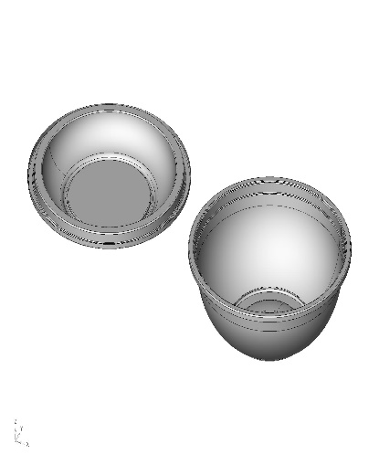
Store Code : PB1000N
Description : 1000 cc Round Salad Bowl
Measure of Product (mm)(inner) : 161*64 mm
Usage Area : Food Separator
Cliche : N/A
Cliche Store Code : -
Product Weight : 19 GR +/- % 5

2.Foil Specification:
- Quality : A Pet Recycle
- Foil Formula : Pet – Ş1
- Color : Black

3.Packaging Specification:

3.1. Box

Box Size | Pieces in Bag | Pieces in Box
573 x 383 x 490mm | 50 | 300

Box Quality : BC-TSSSS STANDART DOPEL
Print: : Standard Print

3.2 Pallet
Pallet Code : P01
Pallet Quality : Heat treated palet
Pallet Size : 80 x 120 cm
Box in Pallet : 20

4. Storage Conditions

Products should be stored on pallets at the room conditions.

Products should protect from sunlight and shouldn’t be stored in wet areas.

5. Transport and Allergen Conditions

Products must be shipped in closed vehicles. Transport vehicles must be dry and clean.

Should not be a bad smell inside the vehicles.

Products does not contain allergen materials defined in Turkish Food Codex Labelling Regulation. Foods and Drinks are forbidden in production area and warehouse.

Le 13/07/2018

